Predicting Life Expectancy using Machine Learning

Introduction:

Life expectancy plays an important role when decisions about the final phase of life need to be made. Good prognostication for example helps to determine the course of treatment and helps to anticipate the procurement of health care services and facilities, or more broadly: facilitates Advance Care Planning.

Advance Care Planning is the process during which patients make decisions about the health care they wish to receive in the future, in case the patient loses the capacity of making decisions or communicating about them . Successful ACP enhances the quality of life and death for palliative patients, by providing timely palliative care and documenting preferences regarding resuscitation and euthanasia, among other things .

For family conciliation, knowing the life expectancy of a patient helps the family and the patient himself to prepare for the final moment, also allows palliative care and therapeutic support to be adapted, and thus improve the quality of life.

But also, knowing this information is useful for the efficacy studies of new treatments for the disease. If we do not know what the initial life expectancy was, we cannot determine if a specific treatment has brought him a benefit, and therefore, the lengthening of life expectancy.

Literature Survey:

Predicting life expectancy using machine learning algorithms.Life expectancy plays a major role.

Theoretical Analysis:

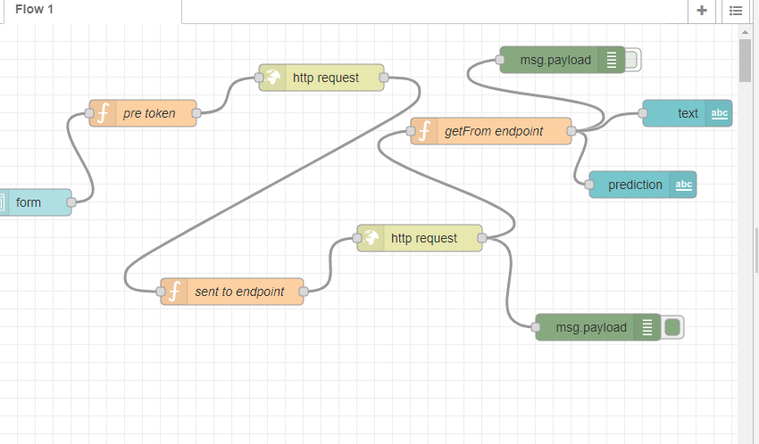

Experimental Investigations:

Life expectancy is one of the most important factors in end-of-life decision making. Good prognostication for example helps to determine the course of treatment and helps to anticipate the procurement of health care services and facilities, or more broadly: facilitates Advance Care Planning. Advance Care Planning improves the quality of the final phase of life by stimulating doctors to explore the preferences for end-of-life care with their patients, and people close to the patients. Physicians, however, tend to overestimate life expectancy, and miss the window of opportunity to initiate Advance Care Planning. This research tests the potential of using machine learning and natural language processing techniques for predicting life expectancy from electronic medical records.

Result:

The accuracy of predicting life expectancy is 83.5%

Conclusion:

There is no single predictor of life expectancy. There are things that contribute to life expectancy that is not in this dataset. But, based on the data used in this project, multiple factors greatly affects the life expectancy. The factors that had the most impact on life expectancy are number of deaths from HIV AIDS, number of years in school, and the body mass index of the population.